# PART: B) ASSIGNMENT NO: 13

**TITLE**: SCALA using Apache Spark framework

# PROBLEM STATEMENT:

Write a simple program in SCALA using Apache Spark framework

# OBJECTIVES:

Students should be able to Write a simple program in SCALA using Apache Spark framework

# PREREQUISITE:

Basic of Apache Spark Framework

# APPRATUS:

Programming Language: Scala Apache Spark Framework

# THEORY:

* **Steps to Install Scala**
* **Apache Spark Framework Installation**
* **Souce Code**

1. Install Scala

Step 1) java -version

Step 2) Install Scala from the apt repository by running the following commands to search for scala and install it.

sudo apt search scala ⇒ Search for the package Search for the package sudo apt install scala ⇒ Search for the package Install the package

Step 3) To verify the installation of Scala, run the following command. scala -version

1. Apache Spark Framework Installation

Apache Spark is an open-source, distributed processing system used for big data workloads. It utilizes in-memory caching, and optimized query execution for fast analytic queries against data of any size.

Step 1) Now go to the official Apache Spark download page and grab the latest version (i.e. 3.2.1) at the time of writing this article. Alternatively, you can use the wget command to download the file directly in the terminal.

wget https://apachemirror.wuchna.com/spark/spark-3.2.1/spark-3.2.1-bin-hadoop2.7.tgz

Step 2) Extract the Apache Spark tar file. tar -xvzf spark-3.1.1-bin-hadoop2.7.tgz

Step 3) Move the extracted Spark directory to /opt directory. sudo mv spark-3.1.1-bin-hadoop2.7 /opt/spark

**Configure Environmental Variables for Spark**

Step 4) Now you have to set a few environmental variables in .profile file before starting up the spark.

echo "export SPARK_HOME=/opt/spark" >> ~/.profile

echo "export PATH=$PATH:/opt/spark/bin:/opt/spark/sbin" >> ~/.profile echo "export PYSPARK_PYTHON=/usr/bin/python3" >> ~/.profile

Step 5) To make sure that these new environment variables are reachable within the shell and available to Apache Spark, it is also mandatory to run the following command to take recent changes into effect.

source ~/.profile

Step 6) ls -l /opt/spark

**Start Apache Spark in Ubuntu**

Step 7) Run the following command to start the Spark master service and slave service. start-master.sh

start-workers.sh spark://localhost:7077

(if workers not starting then remove and install openssh:

sudo apt-get remove openssh-client openssh-server sudo apt-get install openssh-client openssh-server)

Step 8) Once the service is started go to the browser and type the following URL access spark page. From the page, you can see my master and slave service is started. <http://localhost:8080/>

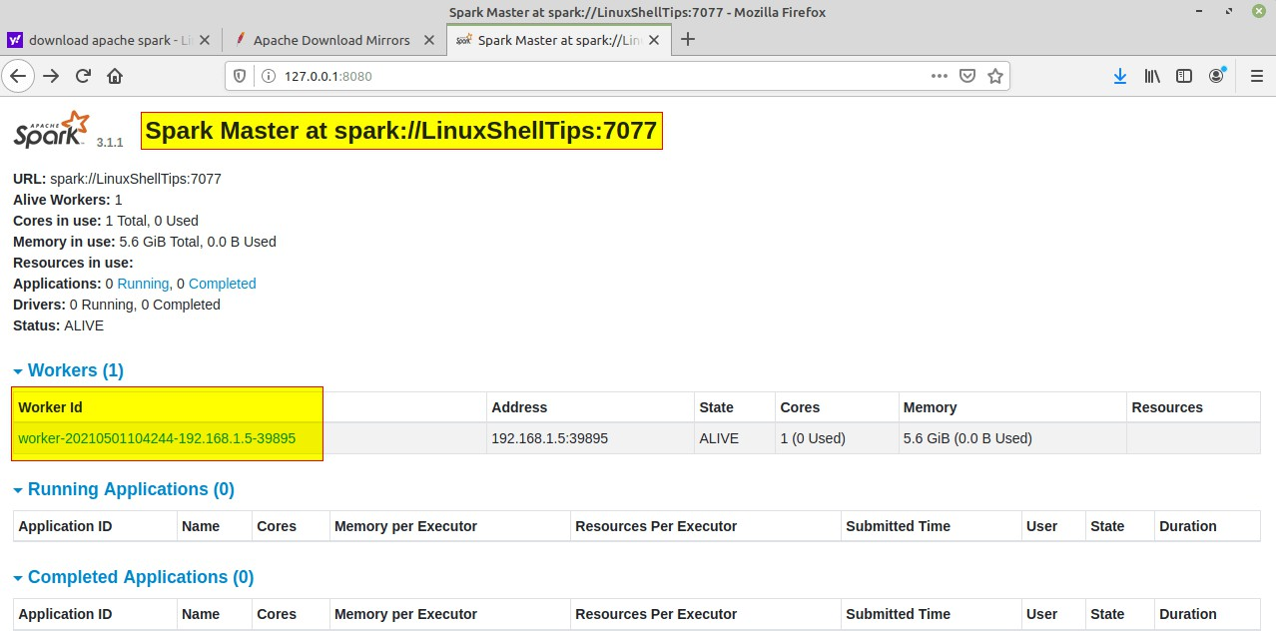

if spark-shell works fine by launching the spark-shell command. Spark-shell

Step 9) You can also check

sudo apt install snapd

snap find “intellij”

sudo snap install intellij-idea-community - - classic Start Intellij IDE community Edition

**Source Code:**

/* Sample Code to print Statement */ object ExampleString {

def main(args: Array[String]) {

//declare and assign string variable "text"

val text : String = "You are reading SCALA programming language.";

//print the value of string variable "text" println("Value of text is: " + text);

}

}

/**Scala program to find a number is positive, negative or positive.*/ object ExCheckNumber {

def main(args: Array[String]) {

/**declare a variable*/ var number= (-100); if(number==0){ println("number is zero");

}

else if(number>0){ println("number is positive");

}

else{

println("number is negative");

}

}

}

/*Scala program to print your name*/ object ExPrintName {

def main(args: Array[String]) { println("My name is Mike!")

}

}

/**Scala Program to find largest number among two numbers.*/ object ExFindLargest {

def main(args: Array[String]) { var number1=20;

var number2=30; var x = 10;

if( number1>number2){

println("Largest number is:" + number1);

}

else{

println("Largest number is:" + number2);

}

}

}